**IFT 466 Advanced Computer Networks**

**Lab 12**

Configure EIGRP on a VLSM network.

Co-authored by Mike Stewart

After you complete each step, put a ‘√’ or ‘x’ in the completed box

1. Setup up the following topology on Packet Tracer

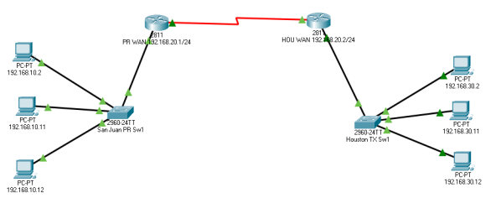



✓

1. On way to create the connection is by enabling a routing protocol between the two routers.   
     
   Some things we need to know:

* PRWANRTR and HOUTXWANRTR connect via a Serial Link and needs to have a WIC -1T module added to the default device.
* PRWANRTR has a serial IP address of 192.168.20.1/30 and home to LAN subnet 192.168.10.0/24.
* HOUTXWANRTR has a serial IP address of 192.168.20.2/30 and home to LAN subnet 192.168.30.0/24
* WAN link between the two routers is on its own subnet, 192.168.30.1/30  
    
   - The link to PRWANRTR is 192.168.20.1/3  
   - The link to HOUTXWANRTR is 192.168.20.2/30



✓

1. Go into PRWANRTR’s CLI and enter the following commands:

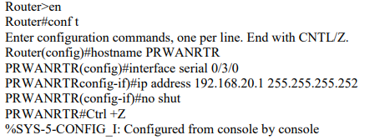

**Note:** The command you just entered is telling the router that if it receives a message addressed to any device on the network 192.168.10.x/24, that it needs to forward it out the port with the address of 192.168.20.1. This establishes a path from PRWANRTR to HOUTXWANRTR. Don’t forget to save your configuration with the: WR MEM command



✓

1. We will enter a similar command on HOUTXWANRTR, so that it has a path back to PRWANRTR.

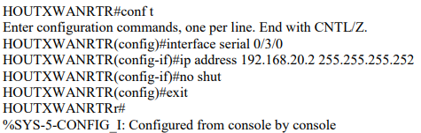

**Note:** Don’t forget to save your configuration with the: WR MEM command



✓

1. Next you must configure your LAN interface. Go into PRWANRTR’s CLI and enter the following commands:

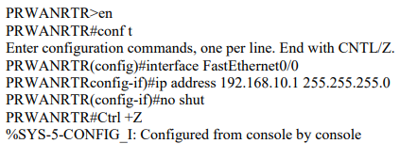

  
  
 ✓

1. Next you must configure your LAN interface. Go into HOUTXWANRTR’s CLI and enter the following commands:

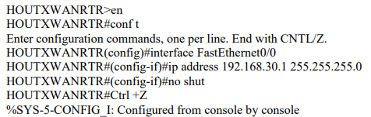



✓

1. Next you must configure your routing protocol EIGRP. You must add the applicable LAN and WAN subnets as neighbors on the router. Go into PRWANRTR’s CLI and enter the following commands:

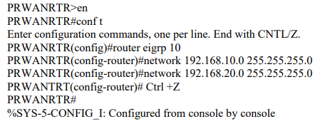

**Note:** Don’t forget to save your configuration with the: WR MEM command



✓

1. Next you must configure your routing protocol EIGRP. Go into HOUWANRTR’s CLI and enter the following commands:

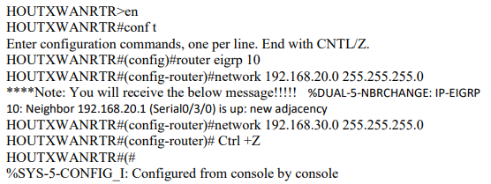

**Note:** Don’t forget to save your configuration with the: WR MEM command



✓

1. Next you must configure your LAN devices for the Puerto Rico office:   
     
   PC IP addresses: 192.168.10.2 – 4   
   Subnet Mask is 255.255.255.0   
   Default Gateway is 192.168.10.1 10.



✓

1. Next you must configure your LAN devices for the Houston office:   
     
   PC IP addresses: 192.168.30.2 – 4   
   Subnet Mask is 255.255.255.0   
   Default Gateway is 192.168.30.1



✓

1. If everything was done correctly, all the PCs should be able to ping remote network regardless of which subnet they are on!

Attached a screenshot of a successful ping from San Juan Puerto Rico Network 192.168.10.2 → Houston TX Network 192.168.30.2 below

